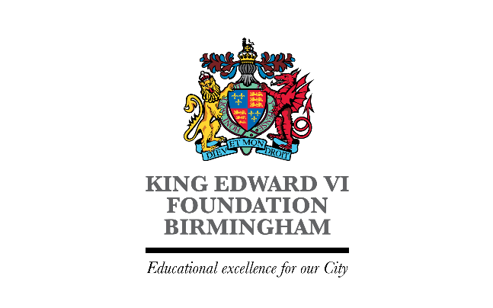

Composition of Foundation Board Committees – 2024-25

Education & Safeguarding Committee
(Quoracy 2 Foundation Governors)
Hywel Thomas
David Wheeldon – Chair
Barnaby Lenon
Fazle Kinkhabwala – Vice Chair

Investment
(Quoracy 3 Governors of which 2 must be Foundation Governors)
Mark Lee - Chair
Hywel Thomas
Gurd Chahal
Sharon Roberts
Jonathan Crawford – Vice Chair
Nicola Ralston – Attendee
Kris Shergold - Attendee

Finance & Estates Committee
(Quoracy 2 Foundation Governors – AT half rounded up)
Barry Matthews – Chair
David Wheeldon – Vice Chair
Gurd Chahal
Sharon Roberts
Erica Conway
Jonathan Crawford
Hywel Thomas

Audit Risk & Compliance Committee
(Quoracy 2 Governors)
Erica Conway – Chair
Fazle Kinkhabwala
David Wheeldon – Vice Chair
Sharon Roberts

People & Systems Committee
(Quoracy 2 Governors))
Fazle Kinkhabwala – Foundation Chair
David Wheeldon
Hywel Thomas – Vice Chair

Remuneration Committee
(Quoracy 2 Governors)
Foundation
Erica Conway –Chair
Sharon Roberts – Vice Chair
Hywel Thomas
Barry Matthews

Governance & Nominations
(Quoracy 2 Governors)
Foundation
Erica Conway
Sharon Roberts – Vice Chair
Hywel Thomas – Chair
David Wheeldon

Executive Committee
Chair – Jodh Dhesi
Foundation
Jodh Dhesi – Chair
Greg Langston – Vice Chair
Sarah Cunningham
Julie Waddington
Grace Cousens
Ather Abbas
Jo Bullock
Deb Canton
Kirsty von Malaisé

